NEW PATIENT

# Objective:

The Smith & Nephew’s NEW PATIENT developed using VBA customizations need to be converted to .NET framework in compatible with AutoCAD 2018, adhering to best practices, supporting 64 bit architectures.

# Overview:

This document gives an outline of input details need to generate required output, working flow and output details of NEW PATIENT module in Smith & Nephew project.

# Description:

# Scope:

NEW PATIENT module is used to update some attribute values (File no, Name, Diagnosis, DOB, Sex, Work Order, Temp Date, Designer) in “MAINPATIENTDETAILS” block reference in the standard template drawing “SN.dwt”.

# Technology:

We are using VB.net technology and AutoCAD 2018 for NEW PATIENT.

# Deliverable:

AutoCAD 2018 customized plug-in DLL.

# Steps to Run:

1. Open AutoCAD 2018 and open a drawing using “SN.dwt” template file.
2. Run NETLOAD command in Command prompt.
3. Load the updated “SmithNephew.dll” file in AutoCAD.
4. Run NEWPATIENT command in Command Prompt.
5. “Patient and Work Order Details” dialog will be opened.
6. In that dialog, Enter the Patient Details (File no, Name, Diagnosis, DOB, Sex) and Work order Details (Work Order, Temp Date, Designer).
7. After entering details, click save button.
8. Now, the attribute values in “MAINPATIENTDETAILS” block reference are updated successfully.

# Dialog Design:

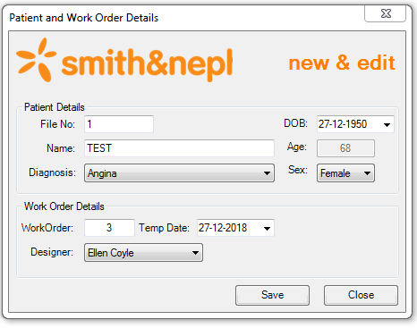

# Required Output